Screenshots

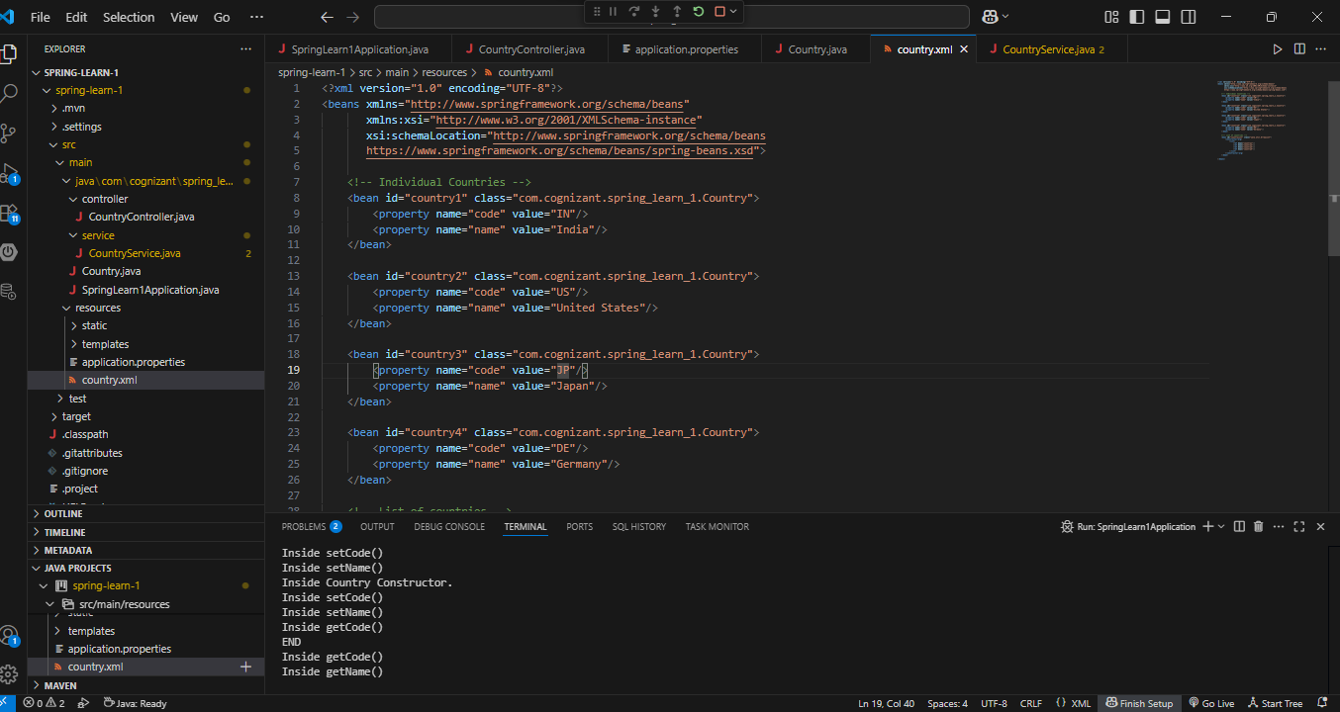

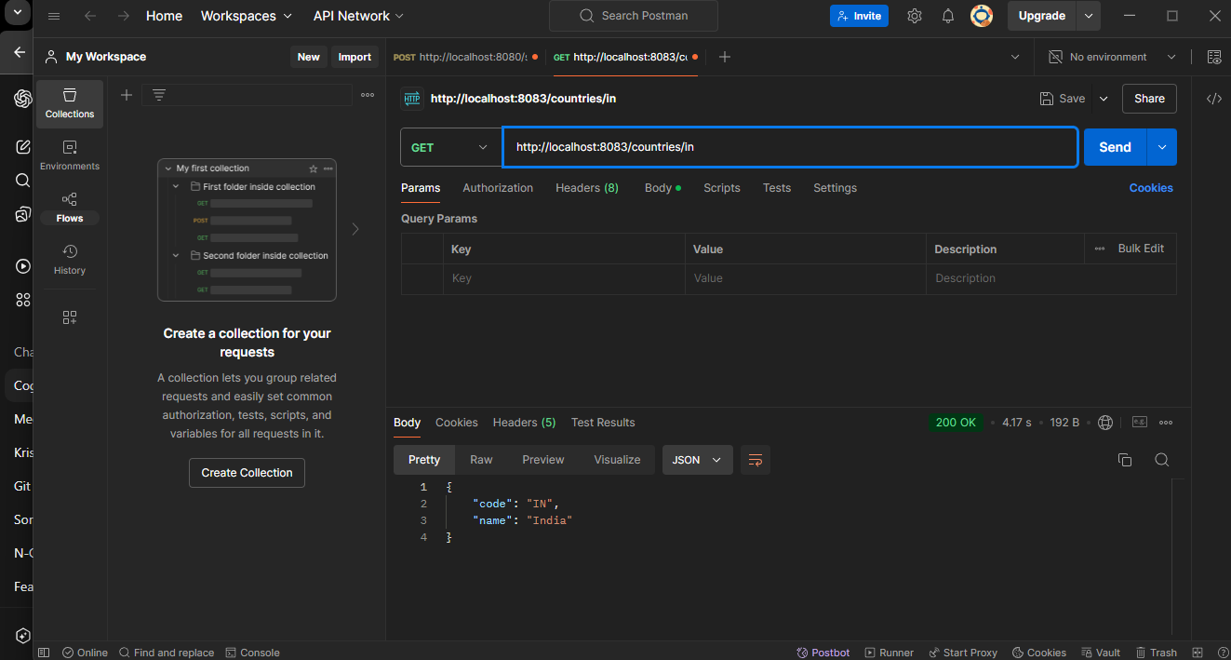

# 🌎 Get Country by Code – REST API (Spring Learn)

## 📄 Description

This Spring Boot-based REST API returns a specific country’s details based on a provided **two-character country code**, which is passed as a path variable. The lookup is **case-insensitive**, allowing requests like `/countries/IN`, `/countries/in`, or `/countries/In` to all return details for India.

The country list is pre-configured in a Spring XML configuration file (`country.xml`), and this endpoint dynamically retrieves the matching country from that list.

### ✅ Endpoint Details

| Method | URL | Path Variable | Response Example |

|--------|-----------------------------------|----------------|-------------------------------|

| GET | `/countries/{code}` | `in` | `{ "code": "IN", "name": "India" }` |

**Sample Request**:

`GET http://localhost:8083/countries/in`

**Sample Response**:

```json

{

"code": "IN",

"name": "India"

}